
vuse GO 800 E-Zigaretten in drei Geschmacksrichtungen
Photo | Marke | EAN | Line | Liquid | VPE / PU | Flavour | Menge | UVP / RRP | UVP-Wert / RRP sum
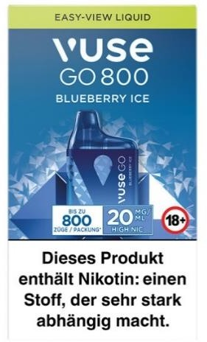 | vuse | 4031300310625 | Go 800 | 2,0ml | 200 | Blueberry Ice | 2.400 | 9,95 € | 23.880,00 €
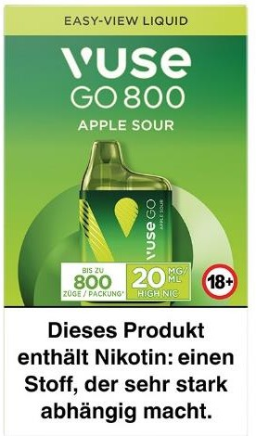 | vuse | 4031300294550 | Go 800 | 2,0ml | 200 | Sour Apple | 2.400 | 9,95 € | 23.880,00 €
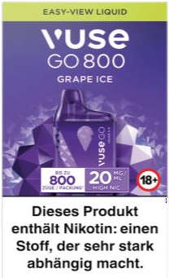 | vuse | 4031300310618 | Go 800 | 2,0ml | 200 | Grape Ice | 2.400 | 9,95 € | 23.880,00 €
Total |  |  |  |  |  |  | 7200 | 9,95 € 71.640,00 €
